**Ideation Phase**

**Define the Problem Statements**

|  |  |
| --- | --- |
| Date | 19 September 2022 |
| Team ID | PNT2022TMID15357 |
| Project Name | Fertilizers recommendation system for disease prediction |
| Maximum Marks | 2 Marks |

**Customer Problem Statement Template:**

Create a problem statement to understand your customer's point of view. The Customer Problem Statement template helps you focus on what matters to create experiences people will love.

A well-articulated customer problem statement allows you and your team to find the ideal solution for the challenges your customers face. Throughout the process, you’ll also be able to empathize with your customers, which helps you better understand how they perceive your product or service.

Reference: <https://miro.com/templates/customer-problem-statement/>

**Fertilizers recommendation system for disease prediction :**

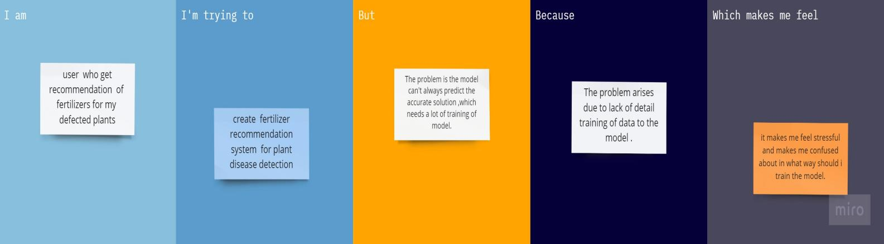

|  |  |  |  |  |  |
| --- | --- | --- | --- | --- | --- |
| **Problem Statement (PS)** | **I am (Customer)** | **I’m trying to** | **But** | **Because** | **Which makes me feel** |
| PS-1 | user  who get recommendation of fertilizers for my defected plants. | create  fertilizer recommendation system  for plant disease detection | The problem is the model can't always predict the accurate solution ,which needs a lot of training of model. | The problem arises due to lack of detail training of data to the model . | it makes me feel stressful and makes me confused about in what way should i train the model. |